Question

Z max = 2061*X*1 + 971*X*2 + 5193*X*3 + 5552*X*4 (Profit)

252*X*1 + 4*X*2 + 13*X*3 + 80*X*499377 (Land)

*X*1 + *X*2 + *X*3 + *X*4100000 (Seeds & Fertilizers)

*X*1 + *X*2 + *X*3 + *X*4103488 (Labor)

*X*1, *X*2, *X*3, *X*40

**The Tolerances for constraints are:**

**P1 = 5%99377 = 4968.85**

**P2 = 5%100000 = 5000**

**P3 = 5%103488 = 5174.4**

**Werner’s approach**

*Z*0 = 39697289.31

*Z*1 = 41682153.77

(Z1 – *Z*0) = 1984864.46

**Formulation:**

0

Membership function of fuzzy objective

0

Graph of the above objective function:

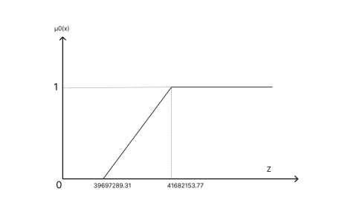

Membership function of fuzzy constraints

**Formulation:**

1

So,

1

2

3

Graph of above membership function:

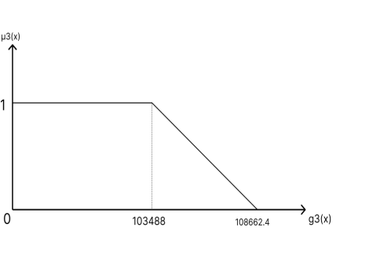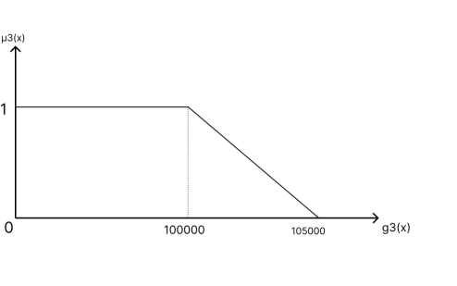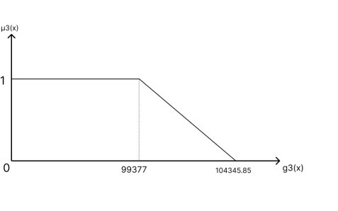

Now, Min

2061*X*1 + 971*X*2 + 5193*X*3 + 5552*X*4 41682153.77 -1984864.46

252*X*1 + 4*X*2 + 13*X*3 + 80*X*499377 + 4968.85

*X*1 + *X*2 + *X*3 + *X*4100000 + 5000

*X*1 + *X*2 + *X*3 + *X*4103488 + 5174.4

*X*1, *X*2, *X*3, *X*40

∈ [0, 1]

**= 0.5; *X*\* = (0, 0,7835.49 , 0);*Z*\* = 40689721.5**

**Resources actually used (101861.37,7835.49, 7835.49)**

**Zimmermann Approach**

Let us assume *b*0 = 40689721.5 at $θ$ = 0.5. Hence, 40689721.5 – 39697289.31=992432.19. So *p*0 must be between 0 and 992432.19. Let *p*0 = 900000.

Membership function of fuzzy objective

**Formulation:**

0

So,

0

Graph of the above objective function:

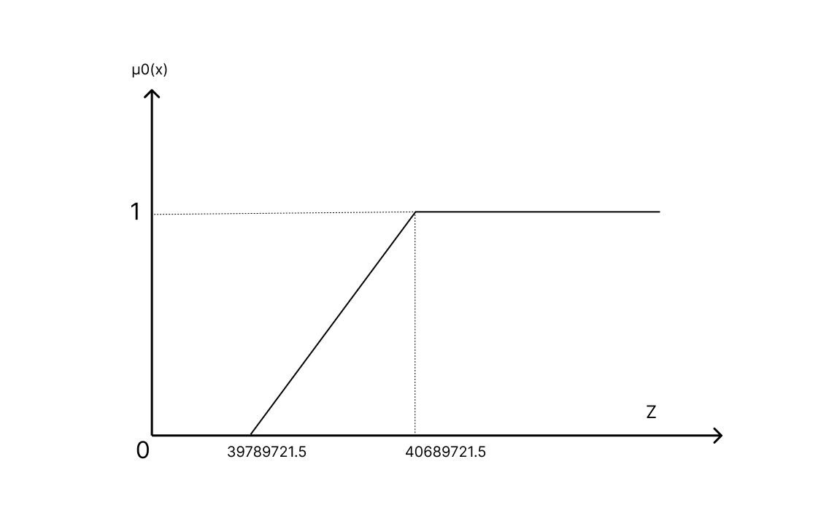

Membership function of fuzzy constraints

They are the same as in Werner’s method solved in above.

Min

2061*X*1 + 971*X*2 + 5193*X*3 + 5552*X*4 41682153.77 -900000

252*X*1 + 4*X*2 + 13*X*3 + 80*X*499377 + 4968.85

*X*1 + *X*2 + *X*3 + *X*4100000 + 5000

*X*1 + *X*2 + *X*3 + *X*4103488 + 5174.4

*X*1, *X*2, *X*3, *X*40

∈ [0, 1]

**= 0.35; *X*\* = (0, 0, 7775.87,0);*Z*\* = 40380092.9**

**Resources actually used (101086.31, 7775.87, and 7775.87)**